**Assignment 2**

Part A

What will the following commands do?

1.echo "Hello, World!"

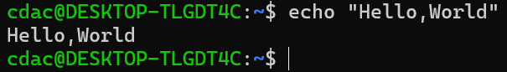

2.name="Productive"

Ans. It stores Productive in var name.

3.touch file.txt

Ans. It creates a new file named file.txt

4. ls -a

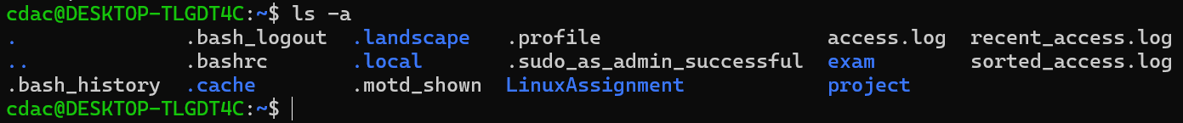

5. rm file.txt

Ans. It delete file.txt

6. cp file1.txt file2.txt

Ans. It copy content of file1.txt to file2.txt.

7. mv file.txt /path/to/directory/

Ans. It move file.txt to the path(/path/to/directory/)

8. chmod 755 script.sh

Ans. It sets the permission for user to read, write and execute. For group and other the permission sets to read and execute.

9. grep "pattern" file.txt.

Ans. it searches for occurrences of "pattern" in the file named file.txt and displays the lines that contain the pattern.

10. kill PID

Ans. The kill command kills a single process at a time with the given process ID. Like kill 1234 – kill the process with process id 1234.

11. mkdir mydir && cd mydir && touch file.txt && echo "Hello, World!" > file.txt && cat file.txt



12. ls -l | grep ".txt"

Ans. The command ls -l | grep ".txt" is used to list files in the current directory and filter the results to show only those files that have a “.txt” extension.

13. cat file1.txt file2.txt | sort | uniq

Ans. It is used to concatenate the contents of two files, sort the combined output, and then filter out duplicate lines.

14. ls -l | grep "^d"

Ans. It used to list all directories present in the current directory.

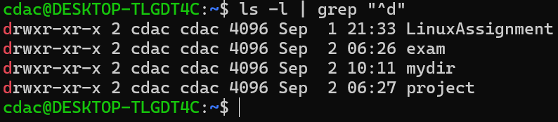

15. grep -r "pattern" /path/to/directory/

Ans. This command is used to search for a specific pattern “pattern” within files in a directory and its subdirectories.

17. chmod 644 file.txt

Ans. It sets permission for user to read and write(4-read, 2-write), for group and others to only read(4-read).

18. cp -r source_directory destination_directory

Ans. This command is used to recursively copy a directory and its contents from a source directory to a destination directory in Linux.

19. find /path/to/search -name "*.txt"

Ans. The find /path/to/search -name "*.txt" command is used to search for files with a “ .txt” extension within a specified directory and its subdirectories.

20. chmod u+x file.txt

Ans. It gives execute permission to the user.

21. echo $PATH

Ans. The command "echo $PATH" allows us to view the current value of the $PATH variable in a Linux system.